The construction of a solar-powered robot that seeks out sunlight to relieve the need for robots to recharging when in remote areas.

Christopher Hunt

Period 1 Biology Honors

Mrs. Littman

12-2-2018

December 2, 2018

Building a light seeking solar-powered robot

**Question:**

Are solar powered robots a feasible solution to the constraints of stationary power sources?

**Background information:**

In the modern world, robots are performing more and more tasks such as construction, transportation, and exploration. Robots are also becoming more autonomous, being able to perform these tasks with less human oversight and control. One of the main obstacles robots have to face when performing their tasks is power consumption and the need to recharge. This forces humans to either have the robots constantly plugged in or close to a power source they can charge from. Although this is not a large problem for robots in factories, it can be a problem to robots operating in more remote areas of the world with little to no access to power or to robots exploring other planets and moons.

One way many robot designers are trying to deal with this problem is installing solar panels on their robots. Robots that use solar panels generally cost less and are more independent (Paula,1997).

In the scientific world, solar cells are known as photovoltaic cells. Photovoltaic cells generate power by utilizing something called the photoelectric effect. It was first recognized in 1839 when Edmund Bequerel, a French physicist, noticed that some materials produced small amounts of electricity when in the presence of light. Albert Einstein won a Nobel Prize in physics in part due to his work on describing the photovoltaic effect. Photovoltaic technology was heavily improved by space programs in the 1960s due to its use on spacecraft. In the 1970s it became popular for “Non-space applications” (Knier, 2008).

When a particle of light, called a photon hits the solar panel, it knocks loose an electron. If conductors are attached to the positive and negative sides of the solar panel, then the electron can flow through the conductors. This creates an electric current which is called electricity. This electricity can be used to power electronic devices and circuits. (Knier, 2008).

This electricity can be measured using a device called a multimeter. When it comes to electricity there are multiple things that can be measured. Because of this there are many units that are used when measuring electricity. Most of the names of these units are based on the thing they are measuring. The most important units are, amps, which measures amperage, volts, which measures voltage, watts, which measure wattage, and Ohms which measures resistance. In the world of electricity there is a famous analogy to help understand what these different units are. It says that an electric circuit is like a tank of water with a hose coming out of the bottom. The water represents electricity and the tank of water represents a battery. Although not a perfect analogy for the other properties of electricity, it works for explaining the units listed above. In this model, pressure, or the amount of force the water in the tank pressing down on the water in the pipe due to gravity is voltage. The difference is that in electricity this force is due to the electrons repelling each other, instead of gravity. The rate, or speed at which the water flows is amperage. The width of the hose is the resistance. The amount of water that comes out of the hose is wattage and wattage is equal to the voltage multiplied by the amperage. Batteries are often labeled with voltage, like 9 volt batteries. In the analogy, a 9 volt battery would be a tank of water that when full, exerts 9 volts worth of force on the water in the hose. As the amount of water in the tank is lowered, it puts less pressure on the water. Similarly, as a battery runs out of power, the voltage it puts on the circuit is lowered. This can be used to measure how much power is left in a battery. Wattage can be used to measure how much power is being produced by something generating power, like in this case, a solar panel.

For this project a robot that’s sole purpose is to survive by finding bright locations to charge its battery with a solar panel will be attempted to be designed and tested. The purpose of this project will be to see how feasible mounting a solar panel on a robot is. This project will also look into whether it is worth it for the robot to seek out sunny locations to charge, or if it would just be better to stop where it is and start charging.

**Hypothesis**:

I believe thatthe robot will function and be feasible but I do not think it will be very efficient. I think that because of my low budget and time constraint that I will not be able to fine tune the design to be efficient but it would show that it would be possible to make an efficient solar power robot.

**Variables:**

**Independent Variable**: If the solar panel is on the robot or on the ground, and if the robot has code to find sunlight or not.

**Dependent Variable**: The amount the voltage, wattage, and amperage changed from the start of each test, to the end of each test, measured at the battery.

**Control Variables**: The amount of and pattern of normal light, the conditions of sunlight.

**Control Group:** The solar panel on the robot will be disconnected from the robot and put in the same conditions as the robot.

**Experimental Group:** The solar panel mounted on the robot.

**Materials:**

* 1 Arduino Uno microcontroller
* 1 Adafruit Motor shield v2
* 4 3-6v dc motors with tiers and gearboxes[1]
* multi-colored wires
* 6 eBoost 5mm photoresistors
* 1 1N5822 diode
* 1 100Ωressistor
* 1 410Ω resistor
* 1 110Ω resistor
* 5 10KΩ resistors[2]
* 1 adjustable 3/6/9/12 volt solar panel
* 1 9v Energizer rechargeable battery
* 3 3x4.5in protoboards
* 2 2x1.5in protoboards
* 1 multimeter
* 1 soldering iron
* solder
* 1 drill
* sandpaper
* 2 11cmx24cm acrylic laser cut sheets
* 2 11cmx23cm acrylic laser cut sheets
* 1 24cmx23cm acrylic laser cut sheet
* 1 Styrofoam board slightly larger than 24cmx23cm
* 1 felt sheet slightly smaller than 24cmx23cm
* 1 hot glue gun

**Procedure:**

**Building the robot:**

All of the steps up through setting up the frame step 6 were performed over the course of the 2017-2018 school year.

**Wiring the protoboard:**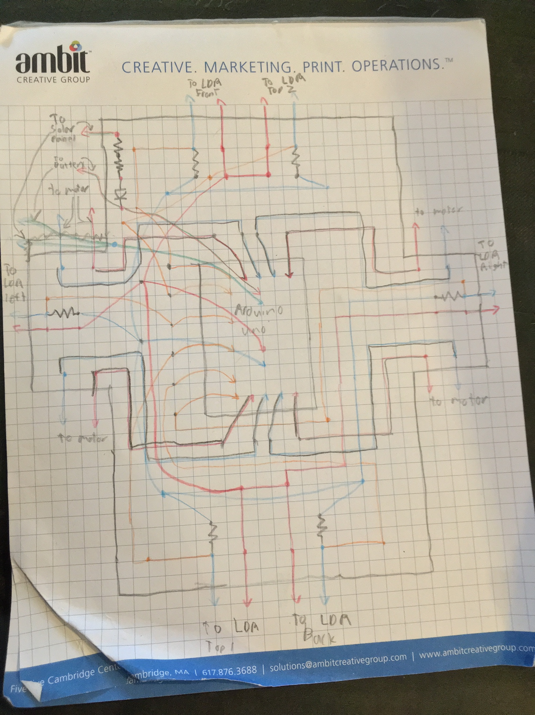

The protoboard is wired as shown above with the wires running along the non-conductive side of the board and the end of the wires threaded through the holes and soldered together onto the conductive rings on the conductive side. Each dot represents the connecting of 2 or more wires/components by soldering. The arrows represent connecting to a component like a motor, or Arduino. The squiggly line represents a resistor. The triangle pointing to a perpendicular line represents a diode. All of the resistors connecting to LDR’s are 10k ohms, except the one going to “LDR back” which is a 110 ohm. It is supposed to be a 10k but the wrong resistor was put on. This can be corrected for in the coding or replaced at a later date. The two resistors going into the diode are a 100 ohm and a 410 ohm. See the materials list to see what the diode is. The diagram is not to scale and the location of some wires relative to others is slightly off. I.e. Some wires might run to the left of another wire in the diagram but on the actual board run on the right.

**Setting up the frame:**

1. Using Elmer’s glue the felt sheet to the top of the Styrofoam board.
2. Hot glue the 4 motors to each corner of the underside of the Styrofoam board with the wheels running parallel to each other.
3. Attach the wheels to the motors.
4. Drill 2 small holes in both of the 23cmx11cm acrylic sheets that line up with the wires sticking out of the short sides of the protoboard.
5. Drill 3 small holes in one of the 24cmx11cm acrylic sheets that line up with the wires sticking out of the protoboard on the long side without the diode.
6. Drill 6 small holes in one of the 24cmx11cm acrylic sheets that line up with the wires sticking out of the protoboard on the long side with the diode.
7. Using acrylic cement, connect the acrylic sheets to form a floorless box 24cm long, 23cm wide, and 11cm tall.
8. Glue the protoboard and 9v rechargeable onto the felt on the Styrofoam board.
9. Place the acrylic box on top of the Styrofoam board with the holes lining up to the corresponding sides.
10. Secure the solar panel onto the top of the box.
11. secure 2 photoresistors to each side of the box.

**Wiring:**

1. Pull the wires through the corresponding holes using tweezers.
2. Connect the wires to the corresponding components by twisting the wires ends together.

**Tests:**

The following steps will be performed in three environments:

1. At the start of each test, the battery will be replaced with a partially charged one.
2. Using a multimeter the amperage and voltage at the battery will be measured.
3. The robot will then carry out these instructions to simulate performing a task:
   1. Move forward for 1 second then stop.
   2. Move forward for 1 second then stop.
   3. Move backward for 1 second then stop.
   4. Move backward for 1 second then stop.
   5. Turn 90 degrees to the left.
   6. Move forward 1 second then stop.
   7. Move backward for 1 second then stop.
   8. Move forward 1 second then stop.
   9. Move backward for 1 second then stop.
   10. Rotate 360 degrees clockwise.
   11. Rotate 360 degrees counterclockwise.
   12. Stay still for 30 seconds.
4. Once the robot finishes it’s spin turn the first timer will be started.
5. During the 30 seconds, Using a multimeter the amperage and voltage of the battery will be measured.
6. Once the robot has been still for 30 seconds it will execute the find sunlight function.
7. Once the robot has stopped moving the first timer will be stopped and a second timer will be started. The time displayed on the first timer will be written down as “time a”.
8. Once the second timer reaches 10 minutes, Using a multimeter the amperage and voltage of the battery will be measured.
9. The robot will have its find sunlight function removed.
10. Steps 1 through 5 will be performed again.
11. Once the new first timer reaches (10 minutes + “time a”) Using a multimeter the amperage and voltage of the battery will be measured.
12. The solar panel will be removed and connected to a discharged battery and placed in the robots starting position.
13. A timer will be set and Using a multimeter the amperage and voltage of the battery will be measured.
14. After the timer reaches (10 minutes + “Time a”) Using a multimeter the amperage and voltage of the battery will be measured.

**The three environments are:**

**Sunny day:**

A flat surface like a basketball court or a parking lot on a sunny day.

**Cloudy day:**

The same location as the sunny day only the weather is overcast.

**Flat open surface with artificial obstacles:**

The same location and day as the sunny day only with cardboard boxes or similar objects blocking the sunlight in all but one direction from the robot.

If a location that fits the following requirements can be found, it may be used as an alternative location:

* A room that can be set up so that the only light is the ceiling light.
* The light has at least a bright, and dim setting.
* Has a flat, not carpeted floor.
* Has enough space so the robot won’t run into anything.

If this room is used,

* The sunny day test will be with the light at full power.
* The cloudy day test will be with the light set to dim.
* The Flat open surface with artificial obstacles test will be with the light at full power with cardboard boxes or similar objects blocking the sunlight in all but one direction from the robot.

| Sunny Day  Raw Data: | Before testing | | | After moving | | | After charging | | |
| --- | --- | --- | --- | --- | --- | --- | --- | --- | --- |
| Voltage | Amperage | Wattage | Voltage | Amperage | Wattage | Voltage | Amperage | Wattage |
| Light seeking robot |  |  |  |  |  |  |  |  |  |
| Robot |  |  |  |  |  |  |  |  |  |
| Solar panel |  |  |  | NA | NA | NA |  |  |  |

| Cloudy Day Raw Data: | Before testing | | | After moving | | | After charging | | |
| --- | --- | --- | --- | --- | --- | --- | --- | --- | --- |
| Voltage | Amperage | Wattage | Voltage | Amperage | Wattage | Voltage | Amperage | Wattage |
| Light seeking robot |  |  |  |  |  |  |  |  |  |
| Robot |  |  |  |  |  |  |  |  |  |
| Solar panel |  |  |  | NA | NA | NA |  |  |  |

| Artificial obstacles Raw Data: | Before testing | | | After moving | | | After charging | | |
| --- | --- | --- | --- | --- | --- | --- | --- | --- | --- |
| Voltage | Amperage | Wattage | Voltage | Amperage | Wattage | Voltage | Amperage | Wattage |
| Light seeking robot |  |  |  |  |  |  |  |  |  |
| Robot |  |  |  |  |  |  |  |  |  |
| Solar panel |  |  |  | NA | NA | NA |  |  |  |

**Works cited:**

Paula, Greg. "Survival of the fittest robot." *Mechanical Engineering-CIME*, Jan. 1997, p. 116. *Science In Context*, http://link.galegroup.com/apps/doc/A19141115/SCIC?u=mlin_m_medhs&sid=SCIC&xid=da4d5f6c. Accessed 2 Dec. 2018.

Knier, Gil. “How do Photovoltaics Work.” *SHARE THE SCIENCE,* NASA SCIENCE, Aug 6, 2008, <https://science.nasa.gov/science-news/science-at-nasa/2002/solarcells>. Accessed 2 Dec. 2018.

1. <https://www.amazon.com/gp/product/B012FYMW54/ref=oh_aui_detailpage_o04_s01?ie=UTF8&psc=1>
2. the 110 should be a 10k but was put on by accident but it can be corrected for in the coding or removed.